**BÀI ÔN TATC KHỐI 3 LẦN 4**

**(TUẦN TỪ 23/3 ĐẾN 27/3/2020)**

**GRAMMAR**

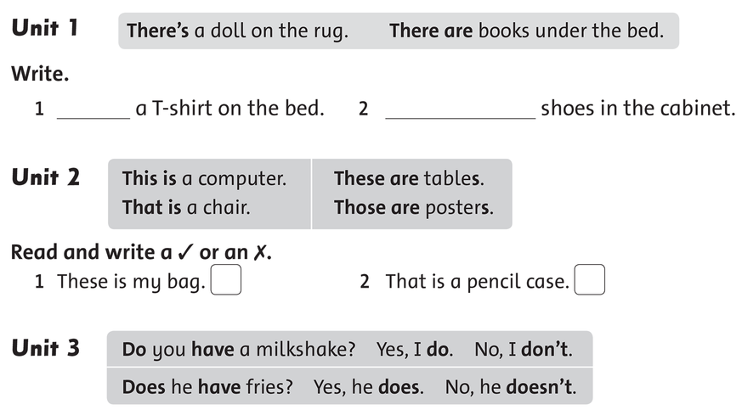

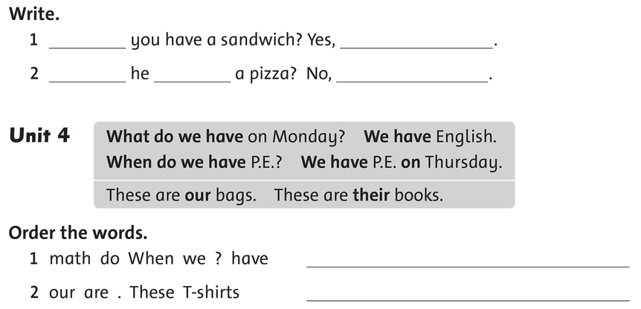

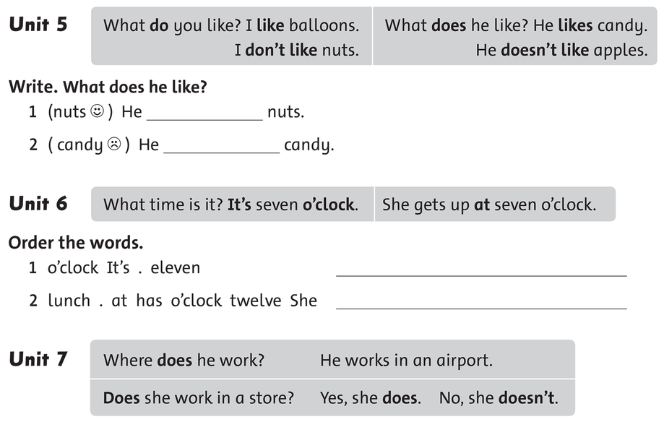

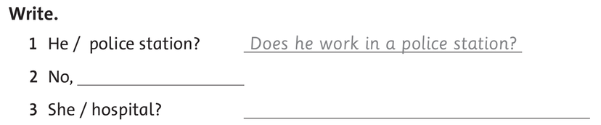

**READING**

**I/ Complete with *have* or *has***

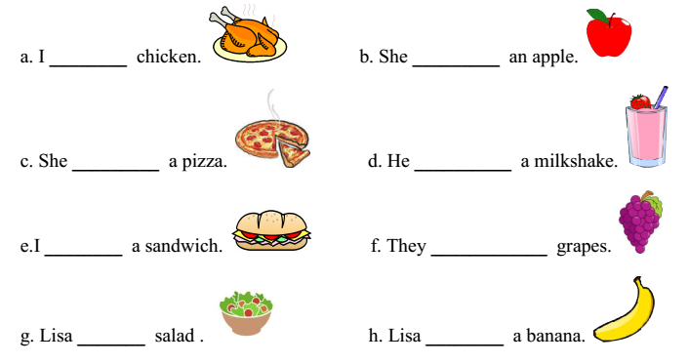

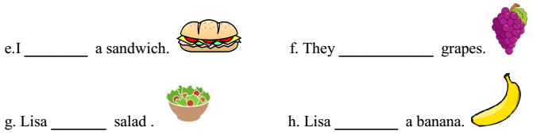

**II/ Reorder the word to make correct sentences**

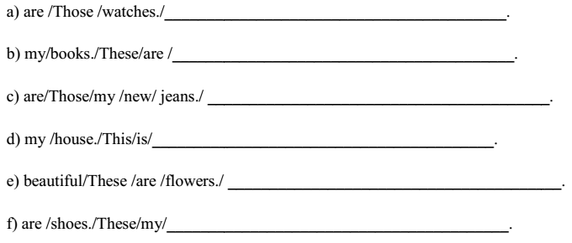

**III/ Find and circle**

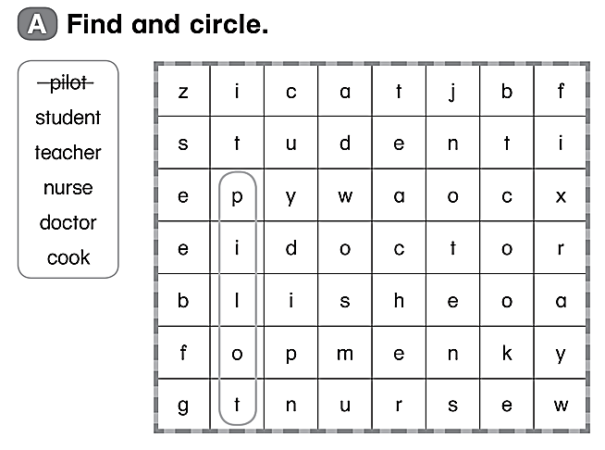

**IV/ Match**

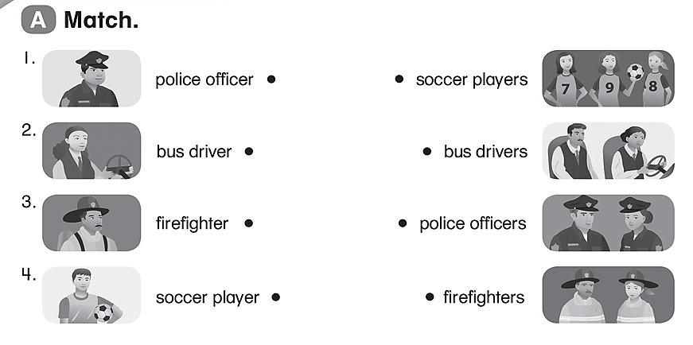

**V/ Look and choose the correct answer**

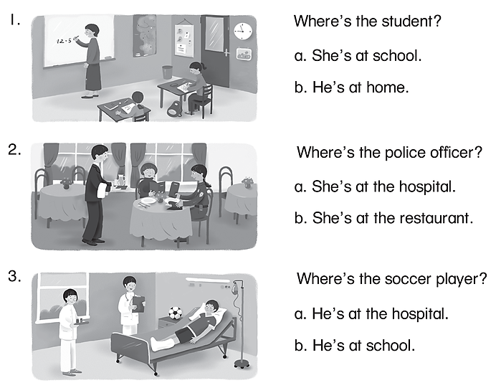

**WRITING**

**I/ Look at the picture and write**

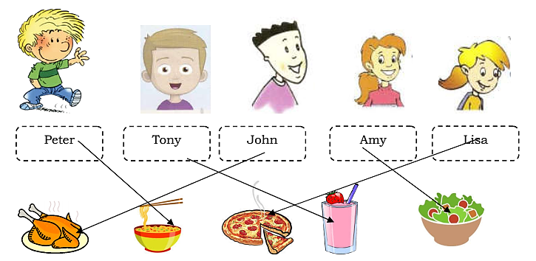

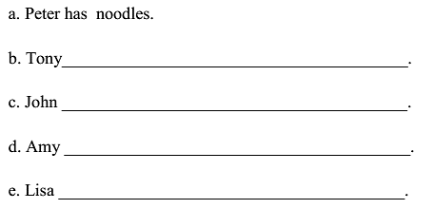

**II/ Look and write**

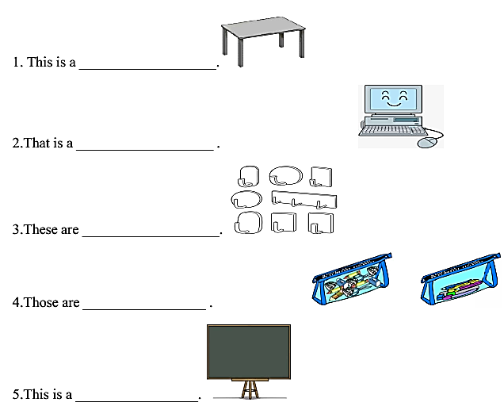

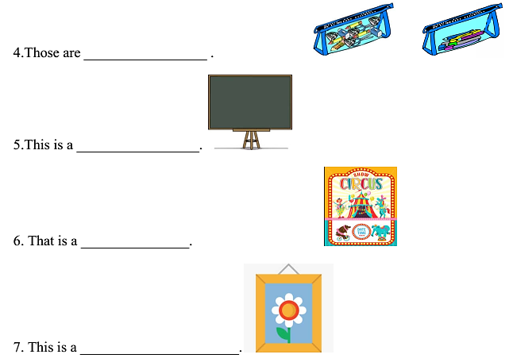

**III/ Make questions and answer for each number**

|  |  |  |
| --- | --- | --- |
|  | What is this? | This is a board. |
|  | What is that? | That is a computer. |

|  |  |  |  |
| --- | --- | --- | --- |
| 1 |  | ______________________? | ______________________. |
| 2 |  | ______________________? | ______________________. |
| 3 |  | ______________________? | ­­­­­­­­­­­______________________. |
| 4 |  | _______________________? | ______________________. |
| 5 |  | _______________________? | ______________________. |

**IV/ Look at the picture and write ONE WORD answer.**

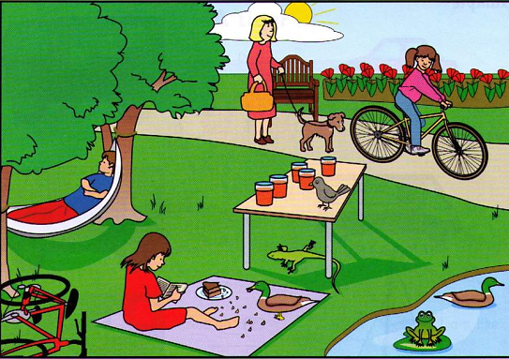

|  |  |  |
| --- | --- | --- |
| 1 | How’s the weather? | ………………………………………. |
| 2 | Where is the dog? | ……………………………….the bike |
| 3 | How many glasses are there on the table? | ………………………………………. |
| 4 | What animal is under the table? | A……………………………………… |
| 5 | What is the boy under the tree doing? | ……………………………………….. |
| 6 | What is the girl reading a book wearing? | A.…………………………………….. |